
VIETTEL PERU

SOFTWARE REQUIREMENTS SPECIFICATION
System name: BITEL E-WALLET
Feature name: CMS WALLET/USER INQUIRY
TRACING TABLE
Day change | Modified by | Description change | Note
07/04/2026 | Truong Thu Huong | New | v1.0
18/04/2026 | Truong Thu Huong | Change UI

PAGE

Author: <Date>
<Title>

Reviewer: <Date>
<Title>

Reviewer: <Date>
<Title>

Approved by: <Date>
<Title>

TABLE OF CONTENTS
1 FEATURE OVERVIEW 1
1.1 Overview 1
1.2 Scope 2
2. FLOW 3
2.1. View wallet list 3
2.1.1. . Sequence Diagram 3
2.1.2. Flow explanation (Sequence) 4
2 INTERFACE (UI/UX SPECIFICATION) 7
Link GA: 7
3 BUSINESS RULE 7
5 EDGE CASE/EXCEPTION 13

RELATED DOCUMENT
NO. | Document name | Version | Last updating date | Note

FEATURE OVERVIEW

Overview
Feature Name: View Wallet List
Description:
This feature allows CMS users to view and manage the list of wallets within the Core Wallet system based on their assigned permissions. The system supports filtering, searching, sorting, pagination, and (if authorized) exporting wallet data. This feature is primarily used for operational monitoring, customer support, compliance checks, and audit purposes.
Actor:
- Viewer
- Operator
- Admin
- Auditor
Entry Point:
CMS → Wallet Inquiry → Wallet List
Preconditions:
- User is successfully logged in
- User has wallet.view permission
Goal:
- Enable authorized roles to monitor wallet data
- Support operational handling (Operator)
- Support system administration (Admin)
- Support audit and compliance review (Auditor)
- Provide read-only visibility (Viewer)

Scope
In scope
- Display wallet list
Out of scope
- Edit wallet information
- Lock / Unlock wallet
- Balance adjustment
- Perform transactions
- Refund
- Retry transaction

2. FLOW

2.1. View wallet list

2.1.1. . Sequence Diagram
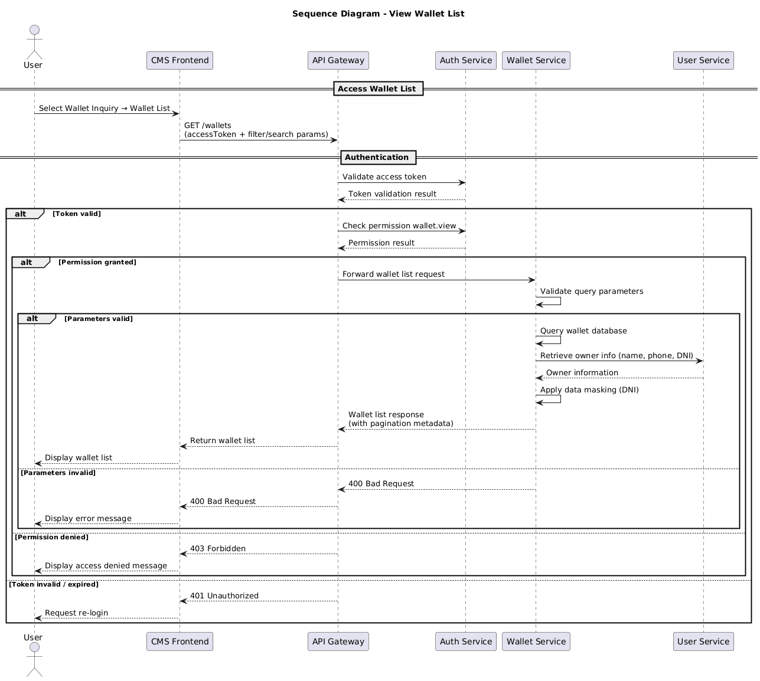

2.1.2. Flow explanation (Sequence)

No | Step | Activity | PIC
1 | Access Wallet List | User selects Wallet Inquiry → Wallet List on CMS | User
2 | Send Wallet List Request | CMS sends GET /wallets request (access token + filter/search parameters) to API Gateway | CMS Frontend
3 | Validate Access Token | API Gateway calls Auth Service to validate access token | API Gateway
4 | Return Token Validation Result | Auth Service returns token validation result to API Gateway | Auth Service
5 | Handle Authentication Result | API Gateway handles authentication result.  5.1. Token valid → Proceed to Step 6  5.2. Token invalid / expired → Return 401 Unauthorized → CMS displays re-login message → End flow | API Gateway
6 | Check Permission | API Gateway calls Auth Service to check wallet.view permission | API Gateway
7 | Return Permission Result | Auth Service returns permission verification result | Auth Service
8 | Handle Authorization Result | API Gateway handles authorization result.  8.1. Permission granted → Proceed to Step 9  8.2. Permission denied → Return 403 Forbidden → CMS displays access denied message → End flow | API Gateway
9 | Forward Wallet List Request | API Gateway forwards wallet list request to Wallet Service | API Gateway
10 | Validate Query Parameters | Wallet Service validates filter, search, pagination and sorting parameters | Wallet Service
11 | Handle Parameter Validation | Wallet Service handles validation result.  11.1. Parameters valid → Proceed to Step 12  11.2. Parameters invalid → Return 400 Bad Request → CMS displays error message → End flow | Wallet Service
12 | Query Wallet Data | Wallet Service queries wallet database based on provided conditions | Wallet Service
13 | Retrieve Owner Information | Wallet Service calls User Service to retrieve owner information (name, phone, DNI) | Wallet Service
14 | Return Owner Information | User Service returns owner information to Wallet Service | User Service
15 | Apply Data Masking | Wallet Service applies data masking to sensitive information (e.g., DNI) | Wallet Service
16 | Return Wallet List Response | Wallet Service returns wallet list response (with pagination metadata) to API Gateway | Wallet Service
17 | Return Response to CMS | API Gateway returns wallet list response to CMS | API Gateway
18 | Display Wallet List | CMS displays wallet list to User | CMS Frontend

INTERFACE (UI/UX SPECIFICATION)
3.1. Wallet/User Inquiry List
(Sample Data) (UI Mock)

Link GA:

BUSINESS RULE
No | Rule | Description
BR-01 | Wallet Type | - USER (PERSONAL)  - MERCHANT  - AGENT  - SYSTEM
BR-02 | Wallet Category | - USER (PERSONAL)  - Main Wallet  - Promotion Wallet  - Gift Wallet  - MERCHANT  - Merchant / Partner Wallet  - Commission Wallet  - SYSTEM:  - Master Settlement Wallet  - Fee Wallet  - Commission Wallet  - Suspense / Pending Wallet  - Promotion Wallet  - Operational Adjustment Wallet
BR-03 | Status | Pending/ Active/ Temporary Blocked/ Blacklisted

- ACCEPTANCE CRITERIA
No | Scenario | Acceptance Criteria
AC-01 | Search User/Wallet | Given Admin enters valid Wallet ID/Name/Phone Number/DNI or RUC  When clicking “Search”  Then system sends request and displays result  Checklist:  - Show loading indicator  - Call API with valid token  - Timeout ≤ 15s  - Data is aggregated before display  - Validate format → If invalid → "Invalid {Wallet ID/Name/Phone Number/DNI or RUC}"
AC-02 | Validate empty input | Given no input is entered  When clicking “Search”  Then system does not call API  And displays: "Please enter Wallet ID/Name/Phone Number/DNI or RUC”
AC-06 | Filter | - Filter by wallet type (BR-01) , wallet category(BR-02) , owner (Name) , status (BR-03) and Balance Ranger
AC-07 | Sort | - Default: Latest → Earliest  - Sort:  + Lastest  + Earliest
AC-08 | Display wallet information | Given wallet data is returned  When rendering UI  Then display wallet information  Checklist:  1. Wallet ID  - Numeric only  - Length 10–20 digits  - Primary key / Unique  - Not null  2. Owner  - Name of owner wallet  4. Type  Refer to BR-01  - USER (PERSONAL)  - MERCHANT  - AGENT  - SYSTEM  5. Category  Refer to BR-02  6. Status  Refer to BR-03  7. Balance (S/):  - Format: #,##0.00  8. Contact  Example  +51 1 2345678  +51 1 9876543  +51-53-4829175  - Must be 9-10 digits  - Must start with +51  9. DNI/RUC  - Null → "--"  - DNI: exactly 8 digits  - RUC: exactly 11 digits  10. Created Date  - yyyy/MM/dd hh:mm:ss
AC-10 | Data not found | Given no data returned  When processing result  Then displays: "User not found"
AC-11 | Multiple results | Given multiple records returned  When displaying results  Then show list or prompt refinement  And displays: "Multiple results found. Please refine your search"
AC-12 | Read-only UI | Given data is displayed  When viewing result  Then all fields are non-editable

EDGE CASE/EXCEPTION
No | Scenario | Edge Case / Exception (EN)
EC-01 | Extremely long input | Very long input string → system handles without UI break and still processes normally
EC-02 | Long display text | Long name/email → truncate with ellipsis (...) without breaking layout
EC-03 | Large balance value | Large balance → properly formatted (#,##0.00) without UI overflow
EC-04 | Null data | Null fields → display "--"
EC-05 | Partial data | User exists but wallet is missing (or vice versa) → display available data + "--" for missing fields
EC-06 | Multiple results | Multiple records returned → display list or prompt user to refine search
EC-07 | Unicode characters | Names with special/Unicode characters → display correctly without encoding issues
EX-01 | No Internet | Display "No internet connection" and allow retry
EX-02 | API failure | Display "System error. Please try again later"
EX-03 | Timeout | Display "Request timeout. Please retry"
EX-04 | Data not found | Display "User not found"
EX-05 | Unauthorized access | Display "Access denied" and block data display
EX-06 | Session expired | Redirect to login and display "Session expired. Please login again"
EX-07 | Invalid token | Treat as unauthorized and redirect to login
EX-08 | Partial service failure | One service fails → display available data + "--" for missing parts
EX-09 | Unknown system error | Display "An error occurred. Please try again"

